**Practical 2**

Write SQL query to retrieve and filtering data from the tables.

***Query 1. Write SQL Query to retrieve & filtering the data from Sales Table.***

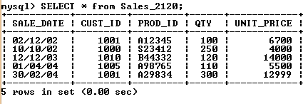

***Query 2. Write SQL Query to retrieve & filtering the data from Product Table.***

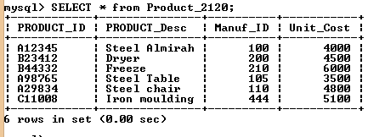

***Query 3. Write SQL Query to retrieve & filtering the data from Customer Table.***

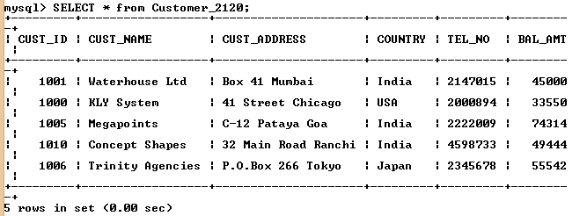

***Query 4. Write SQL Query to retrieve & filtering the data from Customer Table.***

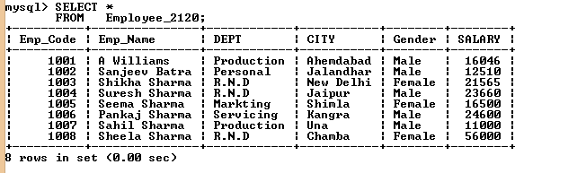

***Query 5. Write SQL Query to show details of Product Dryer from Product_2120 table.***

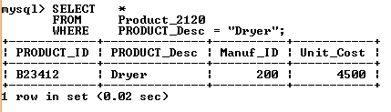

***Query 6. Write SQL Query to get Product _ ID, Product _Name has unit cost 5100.***

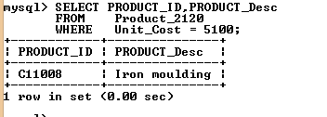

***Query 7. Write SQL Query to retrieve Customer Name who’s resident of country India.***

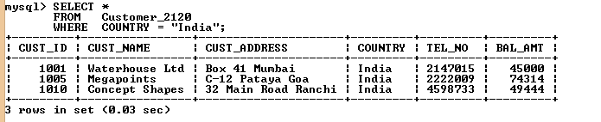

***Query 8. Write SQL Query to show the details of Sales_2120 tables PROD_ID = A98765.***

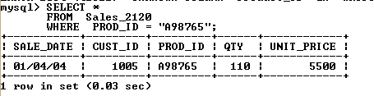

***Query 9.Write SQL Query to retrieve record from Sales_2120 Table of Customer _ ID, Product-ID, Sales on Dated (04/01/04).***

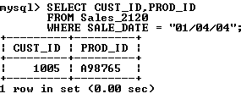

***Query 10. Write SQL Query to list out the name of employees who is working in R.N.D. Department.***

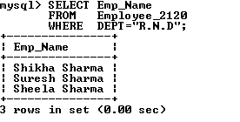

***Query 11.Write SQL Query to list out employee name, employee code and salary of emp those working in Production department.***

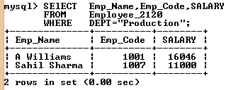

***Query 12.Write SQL Query to List out all detail of customer which have Customer ID=”1005” and living country in India.***

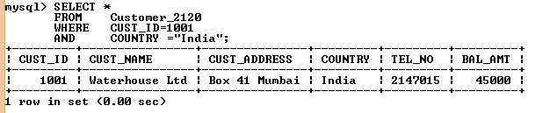

**Query 13.** ***Write SQL Query to List out Name of Emp, Department of employee who have salary grater then 20,000.***

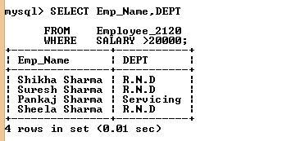

***Query 14. Write SQL Query to get Product _ ID, Product _Name, Mauf _ID has unit cost 5100.***

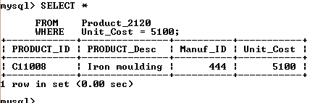

***Query 15.Write SQL Query to list out all details of employee whose Emp_ Name Sahil Sharma OR department is Production.***

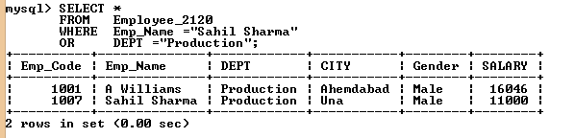

***Query 16. Write SQL query to get the detail of product Steel Chair from Product_2120 Table.***

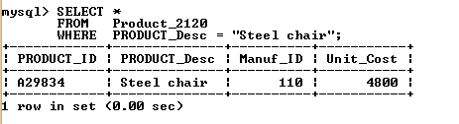

***Query17. Write SQL query to get details of employees who are Male.***

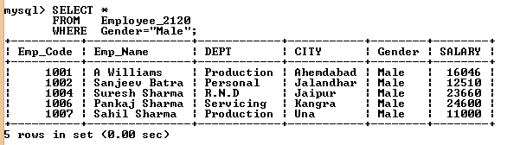

***Query 18. Write SQL query to get details of Unit _Cost is > 4000 but less than 6000***

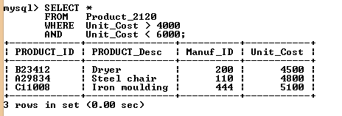

***Query 19. Write SQL query to get details of Employee name and department, which have gender female.***

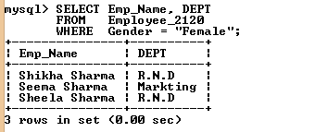

***Query 20. Write a query to get the customer details whose telephone number =2345678.***

